

CHAROTAR UNIVERSITY OF SCIENCE AND TECHNOLOGY

FACULTY OF TECHNOLOGY AND ENGINEERING

B. TECH (IT/CE/CSE/AIML)

Practical : 6
Practical Statement:
• Connect the React Task UI to the Node+MongoDB backend built in
Practicals 4 and 5.
• Replace the GitHub repo data from Practical 3 with task data from your
own backend.
• The application must support creating, viewing, updating, and deleting
tasks from the React interface through API calls.
• All data must be persisted in MongoDB confirmed by refreshing the
browser and seeing data remain.
• Handle loading and error states for every API interaction, not just the
initial fetch.
Screenshots (Supplementary Problems are also implemented):

Deletion popup as task assigned by faculty :
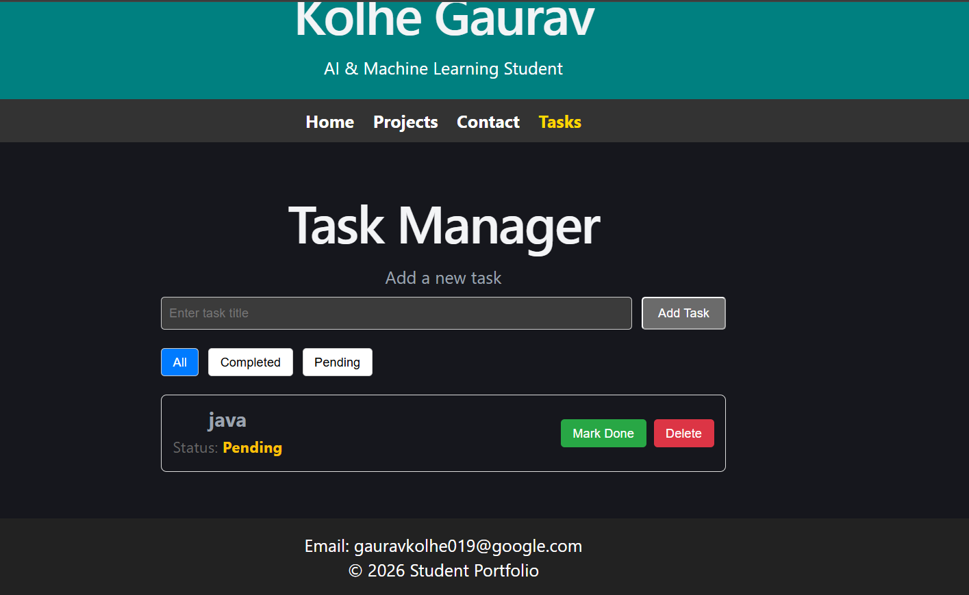
- trying to delete java :



Task Read and Added :
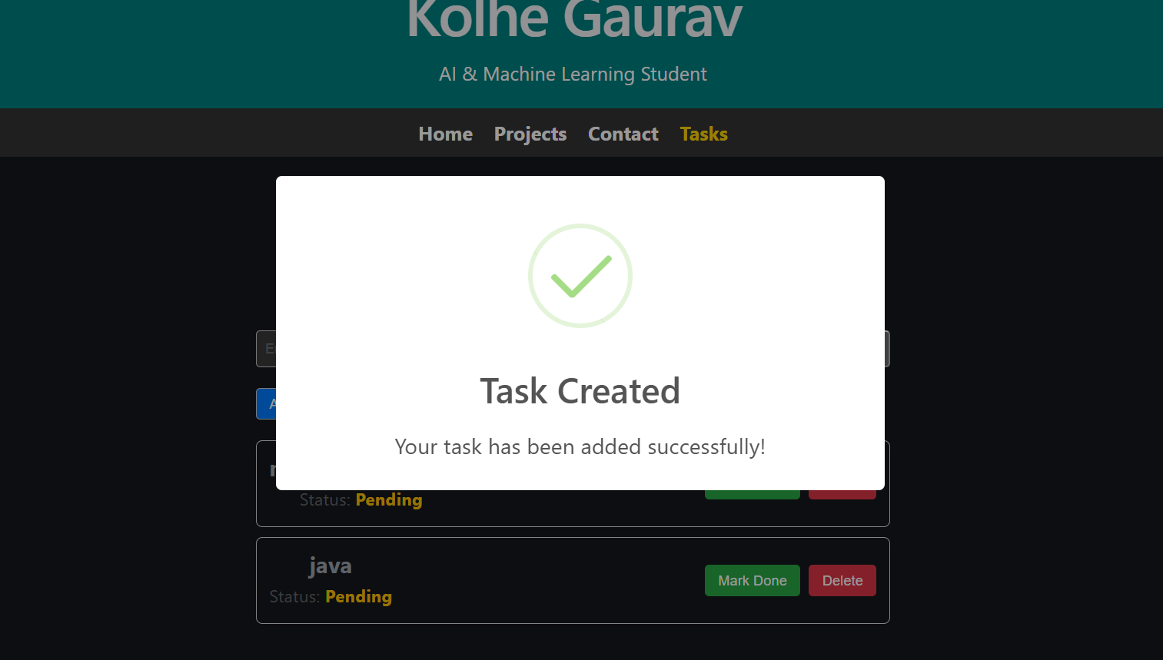
Handled validation error also :
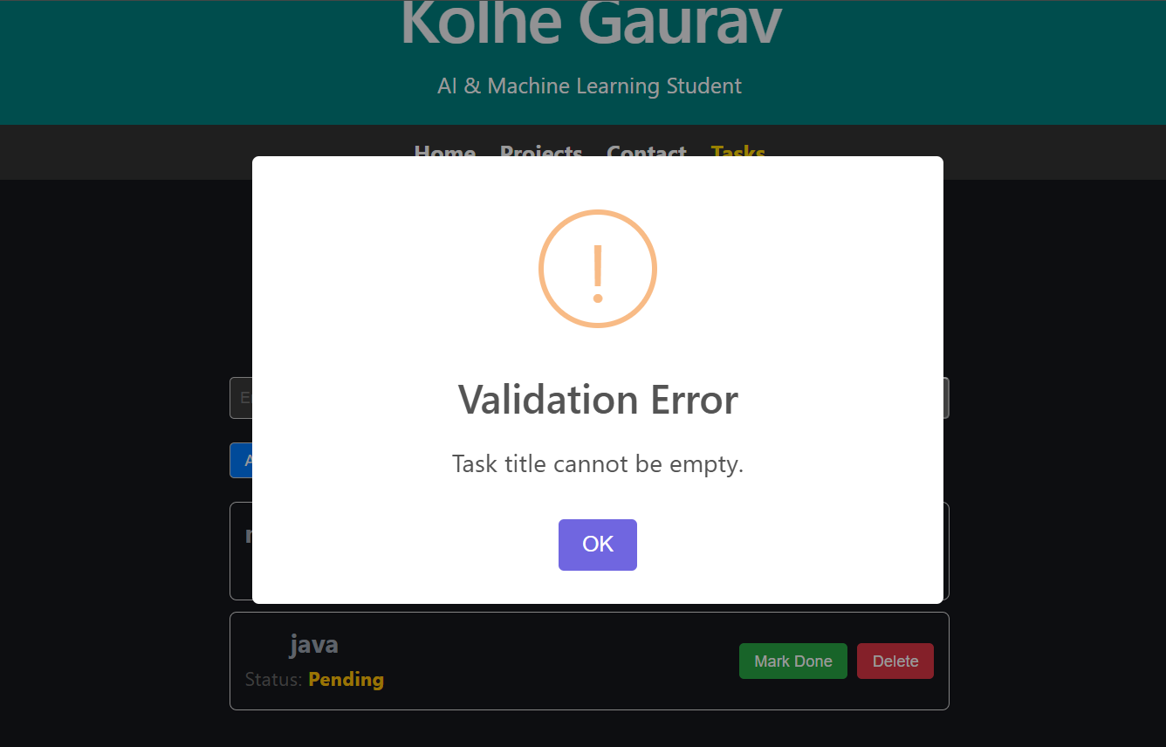
Task update :
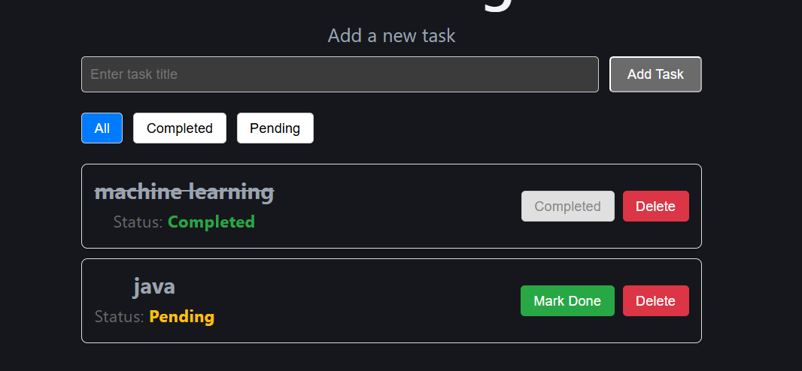
Task delete :
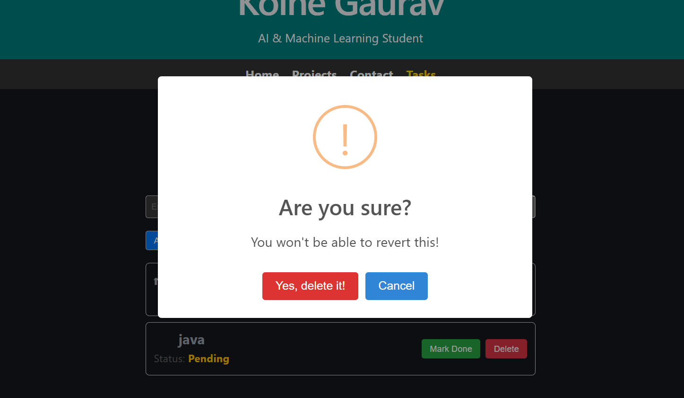

Github Repo Link: https://github.com/Gauravk6531/Advanced-Web-Development-Frameworks/tree/Practical_6

Key Questions:

1. What changes are required on the backend (CORS) to allow the React dev server to call the Express API?
Answer:
The Express backend needs to enable CORS (Cross-Origin Resource Sharing) so that the React development server can make requests to the API from a different origin. This can be done by installing and using the cors middleware in Express and allowing the React development server's URL, such as http://localhost:5173. This tells the browser that requests coming from the React application are trusted and can access the Express API.

2. Why should the UI re-fetch or update local state after a successful POST/PUT/DELETE rather than assuming success silently?
Answer:

After a successful POST, PUT, or DELETE request, the UI should re-fetch the data or update its local state so that the information displayed to the user matches the actual data stored on the server. If the UI assumes the operation succeeded without updating itself, it may continue showing old or incorrect data. Updating the state also gives the user immediate visual confirmation that their action, such as adding, editing, or deleting an item, was completed successfully.
3. What is the risk of not handling errors on write operations (POST/PUT/DELETE) the same way as read operations (GET)?
Answer:
If errors from POST, PUT, or DELETE operations are not handled properly, the application may give the user the impression that their action was successful when it actually failed. This can result in inconsistent UI and backend data, duplicate submissions, lost updates, or incorrect information being displayed. Therefore, write operations should include proper error handling, meaningful error messages, and appropriate UI updates just like GET requests.

